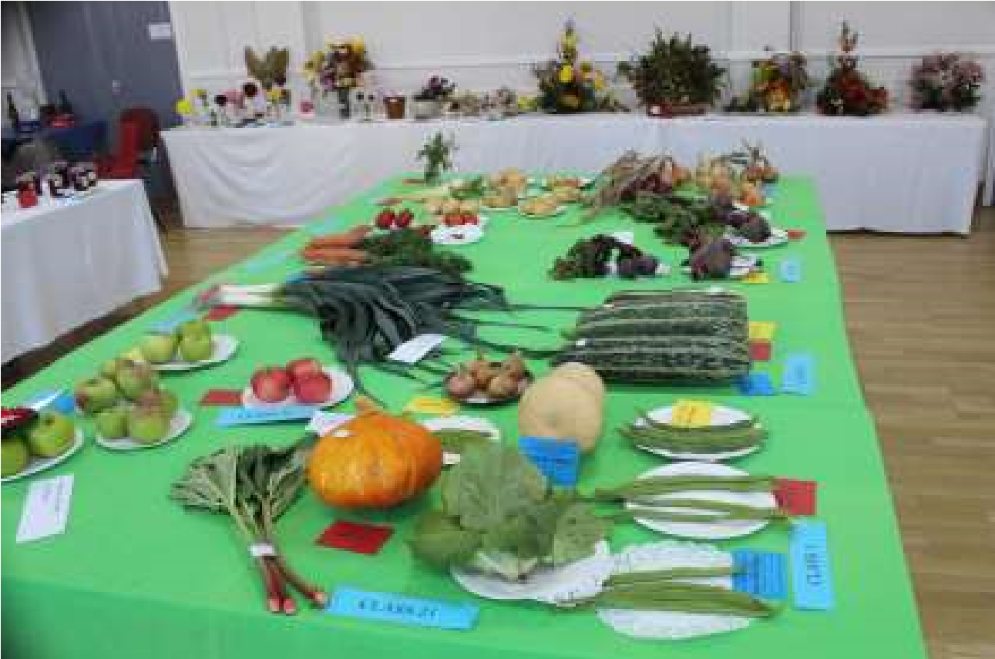

The Newsletter for Middleton on the Wolds

Issue No 42

OCTOBER 2022

NEXT COPY DATE

14th OCTOBER
I have to apologise in advance if this copy of The Messenger is not delivered before the 1st of the month but I am writing this on 14th September while on holiday in Greece. The articles have started coming in and I will get some of the compiling done here but some will have to wait until I am back in Middleton so it will be a bit later than usual going off to the printer.
I am very sorry to be missing the Village Show and hope it is as successful as usual. Thank you to Tina and Lynn who took lots of photos, one of which is on the front page. there will be more in the next issue.
Please send in your contributions by the end of each copy date. If I don’t acknowledge them please get in touch to make sure they have arrived.
Thank you
Lyn
4 The Paddocks 219500 middletonflyer@yahoo.com

ADVERTISING COSTS for the Messenger

Rates Month Year
Whole Page £25 £150
1/2 Page £15 £100
1/3 Page £10 £60

Private 1/4 page private advertisement - £5

Full colour - Print run 500 copies
Contact: Tina 01377 217242, middletonflyer@yahoo.com
If you have any ideas, comments or complaints (especially complaints) you want to share then send an email to middletonflyer@yahoo.com.

Editorial
There has been a lot going on, lately. A new ward councillor – and a Liberal Democrat, at that! A new Prime Minister; and, of course, a new monarch. Not the best of times if you’re not a fan of change.
Diana Stewart is the first non-Conservative ward councillor we have had for some time. Part of the reason for that must
be disillusionment with the party at a national level but does it matter for us in Middleton? Diana replaces Pauline Greenwood who did a great deal of practical work putting, and keeping, pressure on the county council to get work done in the villages for which she was responsible; and she was a Conservative. Now we have a Lib Dem but, quite frankly, Diana could belong to the Monster Raving Loony party (hmmm … No, best not!) all I want from a ward councillor is someone who will work as hard for us as Pauline did. And who will work as a team with our two other ward councillors who are Conservatives.
My personal jury is still out on Liz Truss, but I will admit that she hasn’t taken over at the easiest of times. Apart from having to deal with rising inflation and eye-watering energy costs, she was all set to hit the ground running when everything had to be put on hold because of the sad passing of Her Majesty Queen Elizabeth. However, I await with interest to see how making the rich richer will get us out of this crisis. I wish her luck, but experience doesn’t give me much of a warm feeling; after all, ever since I first heard the phrase, I haven’t seen any evidence of the ‘trickle down effect.’ Hopefully, I will be proved wrong.
And so, we come to the death of Elizabeth II. As I write this the media is full of history and commentary on her life, her family, and how she has shaped the role of a monarch in the modern world. Whatever your beliefs or convictions you cannot deny that, over seventy years, she played the role of Head of State with dignity, consistency and, perhaps most importantly, selflessly. In short, she recognised her duty to the nation and served it to the full. I doubt we will see her like again and it will be fascinating to see how the role of the monarchy evolves under first King Charles III and then his successors.
There is a bit of politics in this editorial so, although I have said it before, I want to emphasise that all the views and opinions above are mine as an individual. Not as a parish councillor; not as a former accountant; and certainly not as a bell ringer! My aim is not to offend but to say what I think, so, if you disagree with anything I’ve said it’s no good complaining to anyone else; speak to me about it or email the Messenger and I will print your answer. Cheers, Mike

QUIZ PAGE
- In what year were London's first Olympic games held?
- Who wrote the novel Frankenstein?
- Who in the Bible was famous for having long hair?
- Which band reached number one in 1981 with brass in pocket?
- The weekly journal of the Salvation Army is called what?
- Who was the first ever foreign coach of the English football team?
- Mount Everest is a part of which mountain range?
- What is a fencing foil called?
- Which county is known as the Garden of England?
- Fred and Ginger who?
Quiz set by Rowland Wooldridge
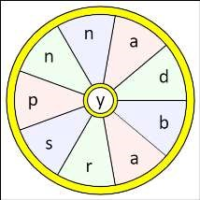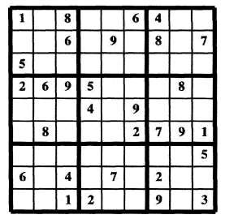
All answers on
page 15

SEASONAL WORD WHEEL

Try to find the timely word or words
and then create as many words
possible with the letters in the word
wheel. You can only use each letter
once and every word must include the
letter in the centre of the wheel.

SUDOKU

St Andrew’S church
Services for October
Sunday 2nd | 10.30am | Morning Prayers. Roger
Sunday 9th | 10.30am | Harvest Festival. Rev’d Jane Anderson
Sunday 16th | 10.30am | Holy communion.
 |  | Rev’d Canon Kate Goulder
Sunday 23th | 10.30am | Morning Prayers. Lesley
Sunday 30th | 10.00am | South Dalton. Benefice Service of
 |  | Thanksgiving for the Departed. Benefice
 |  | team

The wolds METHODIST CHURCH
Services for October
 | Sunday 2nd 10.30am | United Harvest Thanksgiving Service at St
 |  | Andrews Church Bainton, followed by a Bring &
 |  | Share Lunch
 | Sunday 9th 10.30am | Service at the Wolds Methodist Church.
 |  | Pastor John Gleaves
 | Sunday 16th 10.30am | Service at the Wolds Methodist Church.
 |  | Mr Stephen Byass
 | Sunday 23rd 9.00am | Café Style Worship at the Wolds Methodist
 |  | Church. Pastor John Gleaves
 | Sunday 30th 10.30am | Service Wetwang Methodist Church. Mrs Irene
 |  | McGowan
COFFEE MORNING
at The Wolds Methodist Church Bainton Wednesday 19th October
10.00am to 11.30am All Welcome

a note from your vicar
Harvest Festivals
This year St Andrew’s Church,
Middleton will be holding our Harvest Festival on Sunday 9th October at 10.30am.
It will be a traditional service (no Holy Communion) with well- known Harvest hymns – a celebration of the produce of the earth and those who nurture and provide it. Do come along – everyone is welcome.
Middleton Parish is part of the Benefice of Woldsburn which is made up of six parishes, each of our churches celebrate Harvest in their own way. If you cannot make Sunday the 9th please do join us at another church, it would be lovely to welcome you. Here are the details:

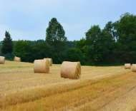
St. Andrews, Bainton
10.30am Sunday 2nd October

St Michael & All Angels, Garton on the Wolds
7pm Thursday 6th October

St. Andrew, Middleton on the Wolds

10.30am Sunday 9th October

All Saints, Kilnwick
6.30pm Thursday 13th October in Church, followed by Bring and Share Supper in the Village Hall

All Saints, North Dalton
7pm Friday 14th October in North Dalton Village Hall Very short service with Supper & Auction of Harvest Produce

St Mary, Kirkburn 7pm Friday 21st October in Church, followed by Harvest Supper in the Village Hall

Jane
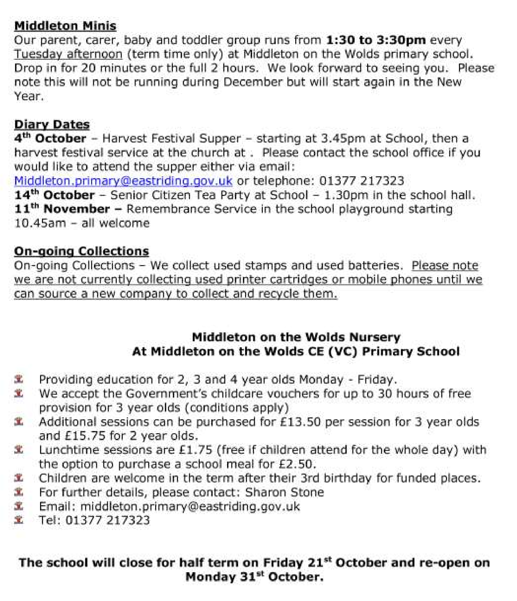
Middleton on the wolds ce ve school
Executive Headteacher: Mrs E Harros

Station Road, Middleton on the Wolds, Driffield YO25 9UQ

E
-
mail:middleton.primary@eastriding.gov.uk Tel: 01377 217323

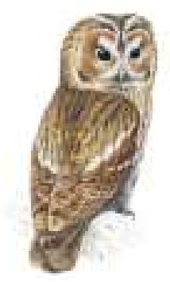
Local Birds & wildlife

The summer seems to have come to a bit of an abrupt end doesn’t it? Suddenly all the young birds have dispersed and the parents, exhausted after a busy summer have all gone off on cruises, and are _{Tawny Owl} sitting in deckchairs sipping cocktails.
Well, I must admit to not being entirely honest there - in fact they are now moulting, getting rid of worn feathers and growing new ones to protect them through the winter. While they are losing old feathers they are more
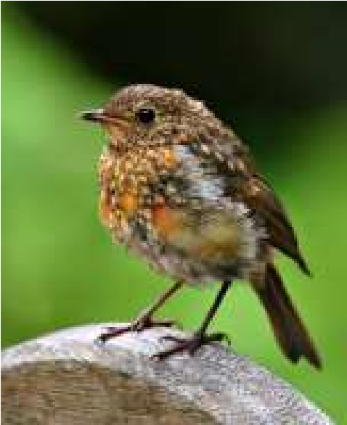
vulnerable to predators as their new flight feathers are growing so they tend to skulk about out of sight more of the time. When you do see them they often have a mix of old and new feathers which can make them more difficult to identify. This year’s young birds will also be getting their adult feathers. Some young birds only have a partial moult, for instance young robins lose their brown spotty body feathers which will be replaced by a nice new bright red breast but keep their wing feathers for the year. More drastically, Puffins fly out to sea, where their beaks drop off! Actually it is just the colourful plates which everyone recognises; the beak that is left is a lot smaller and a grey colour. So they don’t have to suck sand-eels through a straw or anything.
The tawny owls have been calling more over the last few weeks. The ‘toowit’ call being the females and the wavering ‘wooo’ sounds being the males. For a long time I have only heard the males, but last night the first female turned up at my end of the embankment so I expect things to get noisier from now on!
If the sayings about plentiful berries in the autumn are true, it looks as if we could be in for a hard winter! The hawthorn bushes seem particularly laden, and the berries seem to be turning red earlier this year – or is that my imagination? It seems a bit early as I write this to be looking out for the winter migrants – fieldfares and redwings – who usually descend in droves and strip the bushes, so the native birds might have a chance to get well fed
email: middletonflyer@yahoo.com page 8
before they arrive this time.
I expect more of us will soon be putting feeders out in the garden and there will be more sightings to report. Linda saw six red kites circling above; that must have been really spectacular! I was also jealous of Sheelah, whose garden suddenly filled up with sparrows one afternoon. It would be interesting to know how many gangs of sparrows there are around the village. I imagine that to find out would require door-to-door enquiries by earnest people wearing reflective tabards and clutching clipboards however, so we may never know – unless you would like to report your own observations?
Send me those, and anything else of interest around the village, or any questions which I will try and find out the answers to, Barbara lavenderbarbara97@gmail.com or 0777 192 7868

LOCAL HISTORY

UNCERTAIN TIMES

We do not know how the new religious institutions and practices were viewed by the population at large but change can upset people and the north of England tended to be loyal to the old faith. Before examining the reaction however it is worth looking at two religious houses near to Middleton which were victims of the changes

At Warter the Augustinian Priory was founded by Geoffrey Fitzpain in 1132 and the papal bull issued by Innocent the second in 1140 confirmed the property rights for the canons residing in the Church of St. James. The canons affiliated themselves to the order of Arrouise, a French house which followed a strict way of life based on the rule of St Augustine of Hippo. Later the canons known as the Austin Canons acquired land at Middleton (Kiplingcotes) where sheep were kept and wool exported to the continent.

At Nunburnholme there was a Benedictine nunnery which appears to have been in existence by 1200; and it is said that nuns in the East Riding were more often of gentle birth than monks. .By way of example, in 1535 William Hungate of North Dalton, gentleman, bequeathed a dowry to the Prior of
email: middletonflyer@yahoo.com page
Watton in order for his daughter to become a nun in that house.

By the 1530s it was suspected that a royal campaign against the monasteries was a distinct possibility and Archbishop Lee visited both institutions in 1534 with a view to ensuring that their conduct was beyond reproach following earlier reports of lax behaviour when injunctions were issued. Two officials of Thomas Cromwell the king’s minister; Richard Clayton and Thomas Lee inspected all religious houses in 1536 in order to discover anything disreputable; evidence of sexual impropriety was found at both. Warter and Nunburnholme were surrendered on the 11th August 1536 by William Holme and Elizabeth Kilborne respectively.

After dissolution the nuns received a pension and retreated into private life; but the canons did not receive money and tended to take up religious duties elsewhere. Most of the buildings of the suppressed houses were dismantled by Richard Bellycis, servant of Thomas Cromwell, and the distribution of the spoils tended to materially benefit the local nobility and gentry. In summing up the King’s actions Bishop Fisher said; “it is not so much the good as the goods of the Church that he looked after.”
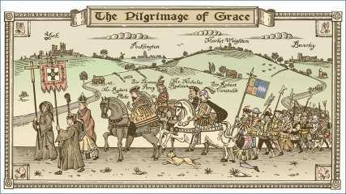
The reaction in 1536 to these changes, an uprising known as the “Pilgimage of Grace”, was motivated not solely by religious concerns; and as a present day Catholic historian has said “Their rising was not so much an effort to force the Crown to revisit its religious policy as a protest against economic grievances. Indeed when we look at Cromwell’s reports and are thus able to see rhe Reformation at a local level, we find not so much a religious conflict

as a complicated morass of personal feuds and grudges, jealousies, rivalries of jurisdiction, provincial contests and sheer bloody mindedness”.

The rising, which started in Lincolnshire, was led by Robert Aske the attorney son of Sir Robert Aske of Aughton near Selby and it is said that thousands of rebels were active in East Yorkshire aided by the upper echelons of local society often acting as figurehead leaders. There was much action of an intimidatory nature on the part of the rebels in Beverley; and among the other local supporters was John Hallam, a yeoman farmer of Cawkeld, Kilnwick, said to be “so cruel and fierce a man among his neighbours that no man dare disobey him.” Hallam took exception to Robert Holgate, Prior of Watton who, following the king’s injunction, failed to announce the approaching feast of St Wilfrid; a man especially honoured in East Yorkshire; the Prior, because of the ferocity of Hallam’s attack backed down and made the announcement.

The story of the rising is complex and ultimately Aske was too trusting of Henry who, because he lacked a strong army, could have been defeated by the conspirators along with his regime but was nevertheless able by subterfuge to outwit his opponents. After the inevitable trial Aske was dragged through the streets of York and hanged at Clifford’s Tower; and Hallam also had a slow death hanging in chains from the walls in Hull. There were other executions of course which was no surprise coming from “ the only prince in modern times who carried judicial murder into his bed, and imbrued his hands in the blood of those he caressed.”

It is said that the parish priests of the late Middle Ages were mostly men of simple faith; low incomes and limited learning; whereas the Protestant newcomers were better trained and in later times university educated. During the years 1530 to 1558 Robert Barra is listed as the rector in Middleton with James Barra as his curate. They were succeeded in 1570 by Robert Phillips; John Bucke in 1571 and Gilbert Ward in 1588 who lasted until 1601. Their views on the changes to the church interior with the plundering of all but basic items necessary for worship; religious practice; and the Miles Coverdale bible in English are not known.

Catholic resistance to the changes remained strongest in North and West Yorkshire whilst East Yorkshire was more amenable; however two cases of local recusancy were brought to the attention of the authorities in later years one in North Dalton and that of Frances wife of Joe Gillson of Middleton.

Geoff Wisher

Middleton book group
The Midnight Library by Matt Haig
Between life and death is a library. Nora Seed finds herself there after attempting suicide when she is feeling that life has no meaning for her. She is given the chance to try several differing life styles, revisiting the library between each life as it disintegrates. Each life has people in it from
her real life and she learns how to live a full life. At the end, will Nora recover or ••••••?

The Storyteller of Casablanca by Fiona Valpy
Set in 2 eras 70 years apart, this is an evocative story of 2 families connected by the same house. During the 2nd World War, Josie and her Jewish family escape from danger in Paris to Casablanca and the story is told through the eyes of a 12 year old. 70 years later, Zoe is struggling to save her marriage and she and her family move to Casablanca to live in the same house. After finding a box under the floor boards, she begins to see Casablanca through Josie’s eyes and gradually is drawn into her life. Patchwork is a theme which flows through the book - The Tree of Life being the pattern that Zoe explores.

I loved both books - couldn’t put them down.

June
The next books for discussion:
Codename Helenė by Ariel Lawhon
The Age of Miracles by Karen Thompson Walker

Meetings are on the second Tuesday in the month, usually in the morning, in member’s homes - Contact Lyn for further details: 219500 or lyndennis456@gmail.com
thank you
Following her fall in the village recently, Eileen Towse would like to thank everyone who stopped to help, and everyone who has called and phoned since wishing her well.

thank you
St Andrews Church
The PCC would like to thank everybody who donated money to the REDCROSS
Collection tin at the post office which is going to help the
UKRAINE.

news from Local villages
Tying up Your Loose Ends:
A workshop on preparing for the end of life in an affirming, practical way
Hi, I’m Sara Scott, a North Dalton resident, village hall committee member and a Humanist funeral celebrant. Whilst helping people to plan funerals, I’ve become more and more aware of how important it is for all of us to prepare for the end of our lives to make things as easy as we can for those we leave behind. Let’s be honest, most of us don’t want to think about these things, but if we do, it can be one of the best ways of supporting the people we care about once we’re no longer around. So, I’m hoping to run a new workshop to help people think about and talk about how to tie up the loose ends.
The workshop will be held on
Saturday November 19th 10.30 – 3.30 in North Dalton Village Hall We will talk about:
-How to deal with future ill-health or incapacity by making an Advance Statement, Advance Decision or Lasting Power of Attorney.
-Having ‘difficult’ conversations with family and friends about death, dying and your wishes.
-‘Weatherproofing’ your Will and leaving instructions for your funeral or memorial.
-Organising the messy corners of life: Passwords, paperwork and possessions
-Having got organised, re-focusing on living rather than dying
£8 per person to cover materials, hall hire, tea, coffee and a sandwich lunch. To book a place please contact Sara by text 07730 885400 or email sara@dmss.co.uk

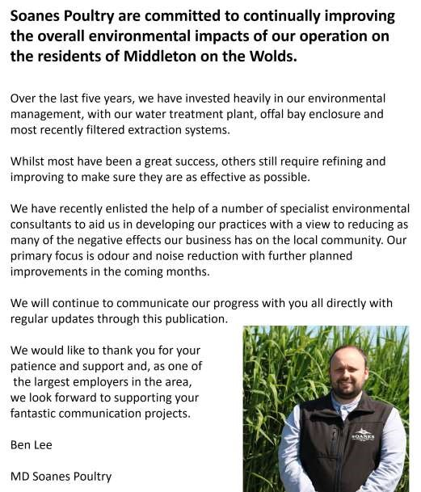
Advertising Feature

Advertisements
Advertisement

Advertising Feature
Regular group activities
Weekly Groups
Monday Pilates |  | 5.00-6.00pm Village Hall
Tuesday Tai Chi |  | 2.30-4.00pm Village Hall
Wednesday Line Dancing |  | 7.30-9.00pm Village Hall
Thursday Middleton Movers  October |  | 2.00-3.30pm Village Hall
3 Parish Council |  | 7.00pm Village Hall
11 Book Group |  | 10.30am Village Farm
 | LOCAL CONTACTS Bell Ringing Chris Atkin |  |  | 217285
 | Book Group/Middleton Movers |  | Lyn Dennis | 219500
 | Bowls Club |  | Rob Bradley | 217435
 | Country Women’s Association |  | Christine Johnson | 217374
 | First Responders |  | Chris Brent | 219469
 | Line Dancing |  | Pat Pottage | 217516
 | Methodist Chapel |  | Jane Gray | 07870 562455
 | Middleton Messenger |  | Mike Kelly | 07713 620912
 |  |  | Lyn Dennis | 219500
 |  |  | Tina Walker | 217242
 | Middleton Green Group |  | Liz Naylor | 219072
 | Middleton Womblers |  | Andrew Naylor | 219072
 | Parish Clerk |  | Sandra Morrison | 01262 470496
 | Pilates |  | Ian Stephenson | 07973 755717
 | Reading Rooms |  | Kath Bentley | 217456
 | Recreation Club |  | Dave Newlove | 07901 833784
 | St Andrew’s Church |  | Rev Jane Anderson | 219471
 | St Andrew’s Church Wardens |  | Chris Brent | 07766 162743
 |  |  | Lesley Kelly | O7907 451046
 | Table Tennis |  | Louise Newlove | 217801
 | Village Hall |  | Lyn Dennis | 219500
 | Village History Geoff Wisher |  |  | 217517

